1. Conduct a one-sample t-tests for mean using an appropriate variable from the data set. Use the t.test( ) in R. Provide the null and the alternative hypothesis for each test. Provide the test results and several sentences interpreting the results.

#H0:mu =45

#Ha:mu ≠45

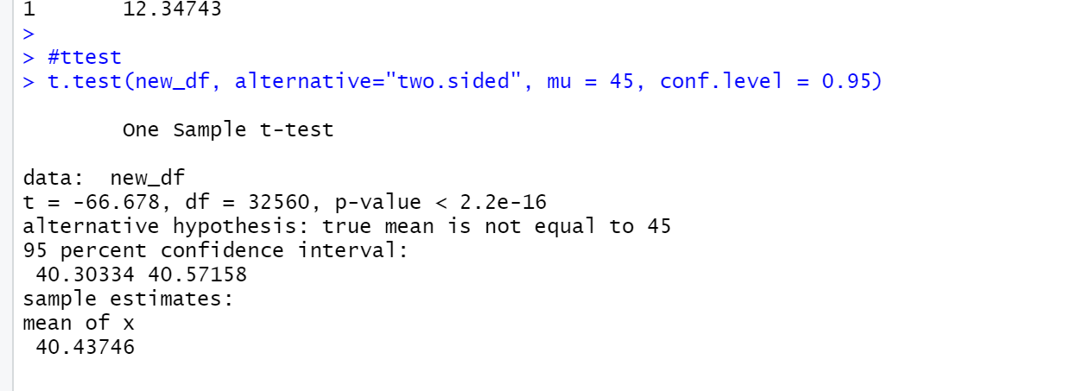

My null hypothesis for the test is the mean value is equal to 45 hour/week, and the alternative hypothesis is not equal to 45 hours/week. From t test, I got t-test value -66.678 is less than the critical value of -1.6449, so at 0.05 significance level, we can reject that the mean is 45 hour/week .

1. Conduct hypothesis testing for p-value using an appropriate variable from the data sets. Do this in R. Provide the null and the alternative hypothesis for each test. Provide the test results and several sentences interpreting the results.

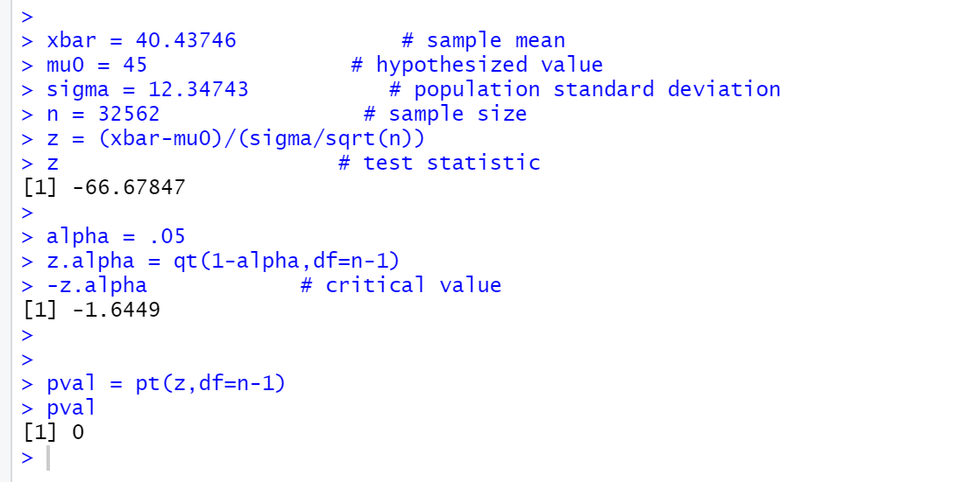

My null hypothesis for the test is the mean value is equal to 45 hour/week, and the alternative hypothesis is not equal to 45 hours/week. Since p-value is less than 0.05 significance level, we can reject that the mean is equal to 45 hour/week.